Microsoft 365 Insights – How to Open

Purpose: Use this Job Aid to open your Microsoft 365 Insights panel.

Steps | Details
1. Open from the Outlook desktop app | a. Open the Home ribbon of Microsoft Outlook.  b. Select the Insights icon.  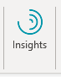
2. Open from the Outlook web app | a. Open Outlook on the web.  b. Open an email message.  c. Select the ellipsis (...) in the top-right corner of your email message, and then select Insights.  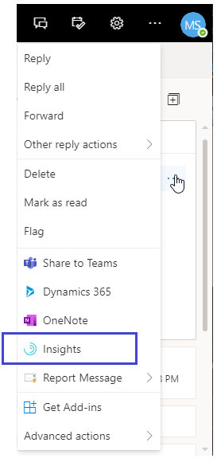
3. Pin to your quick access pane | a. In Outlook on the web, select the Settings icon.  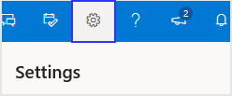  b. In Settings, select View all Outlook Settings.  c. Confirm Mail is selected in the left pane, and in the center pane, select Customize actions.  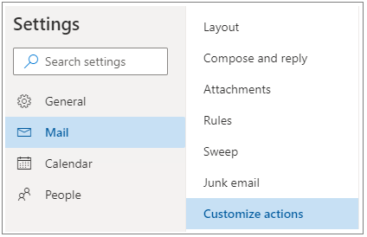  d. In the right pane, in the Message surface area, select Insights.  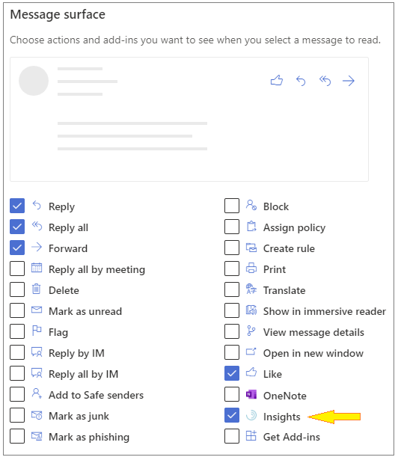  e. In the right pane, in the Toolbar area, select Insights.  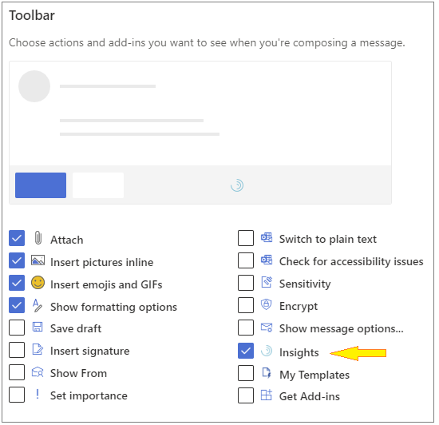  f. Save your new settings.

Microsoft 365 Insights – How to Use

Purpose: Use this Job Aid to customize your Microsoft Office 365 Insights panel.

Steps | Details
1. Prepare for your meetings | Prepare for your meetings shows you a list of upcoming meetings that you've organized or that you've been invited to. This insight helps you decide whether each meeting is ready to go.  a. On the Insights panel, locate Prepare for your meetings. This insight tells you about meetings that you've organized or were invited to for this week and next week (up to 10 business days in the future) and it helps you evaluate the state of those meetings.  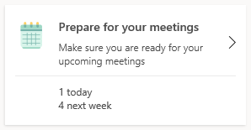  b. Select Prepare for your meetings to see an insight for each of your upcoming meetings. If you are an invitee to meeting, you will see an insight such as this:  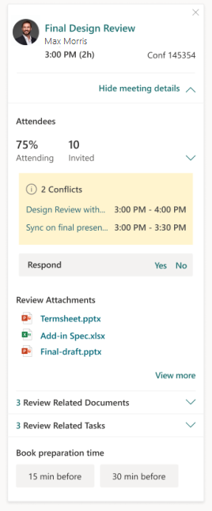  If you are the meeting organizer, you will see an insight such as this:  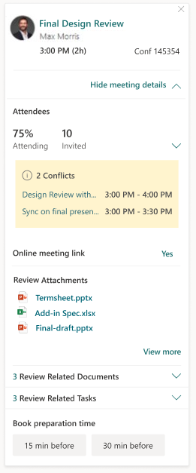
2. Track email and document open rates | Insights can tell you how many people have opened your email and the average time they spent reading that email.  a. If the Insights pane isn't already open, select the Insights icon in the Outlook Home ribbon to open it. If you see a "Welcome!" message, select Get started.  b. In Insights, select one of the following:  1. In-context email open rate - Shows read statistics for the sent email that you currently have open in Outlook. It also provides open rates for linked or attached documents that are stored in OneDrive for Business or SharePoint. In rare cases, the document open rate can be higher than the email open rate. This can happen when recipients open the document through sources other than the email in which it was shared.  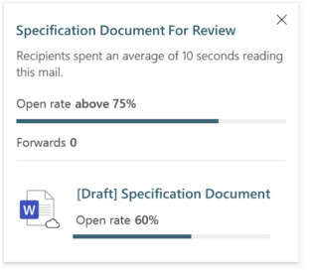  2. Track email open rates - Shows read statistics for all sent emails.  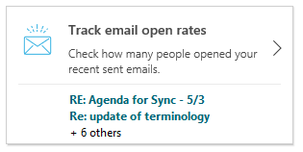  c. The option you selected shows the email subject line and a summary of the open rate, the open rate (sometimes expressed as a percentage), and the number of forwards.
3. View outstanding tasks | Make sure nothing falls through the cracks by seeing reminders of tasks that you've agreed to do.  a. In the Insights pane, select View outstanding tasks.  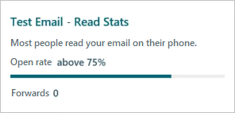  b. This opens a panel that displays insights for each of your suggested outstanding tasks.  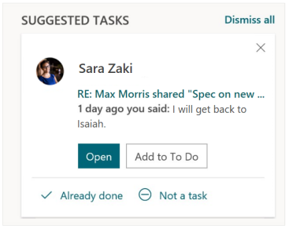
4. Follow up on your requests | Receive reminders to follow up on commitments made by your colleagues or on requests that you have made.  a. In the Insights pane, select Follow up on your requests.  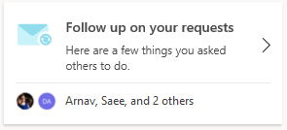  b. This opens a panel that displays insights for each of your suggested follow-up tasks.  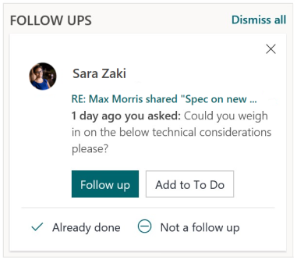
5. Book time to focus | Protect time for focused work and minimize notifications (and thus distractions).  a. In the Insights pane, select Book time to focus. This insight appears if your calendar has time available during your working hours that is not blocked by meetings or appointments.  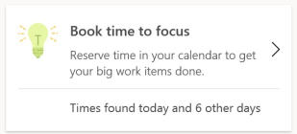  b. This opens a panel that displays all the time available to focus in the coming week, with a couple of available slots every day.
6. Catch up on email | Cut through the clutter with a summary of unread email from your more important contacts.  a. In the Insights pane, select Catch up on email.  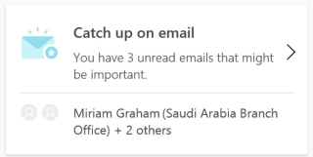  b. This opens a panel that displays insights for each of your important unread emails:  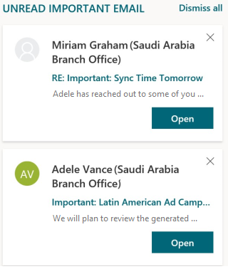
7. Catch up on documents | See a list of shared OneDrive and SharePoint documents that you need to catch up on.  a. In the Insights pane, select Catch up on documents:  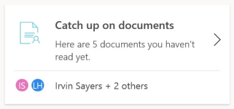  b. This opens a panel that displays insights for each document shared with you in the last 14 days that you have not yet opened.  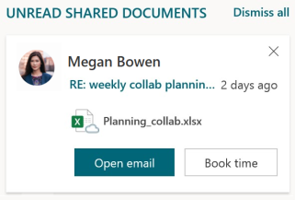
8. Add important people | Manage your list of important contacts. You'll see reminders when you have tasks to complete for these people or unread emails from them.  a. In the Insights pane, select Add important people:  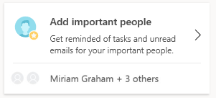  b. This opens a panel with suggestions to mark a recommended contact as important:  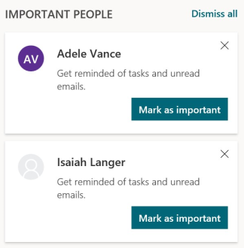
9. Set lunch hours | Use this card to protect your lunch hours and personalize your insights.  a. In the Insights pane, select Settings.  b. In the Set lunch hours area, select the edit (pencil) option.  c. Change the values in the Start and/or End fields.  d. Select Update.  e. To set lunch hours through the Lunch Hours card, in the Insights pane, locate Set lunch hours:  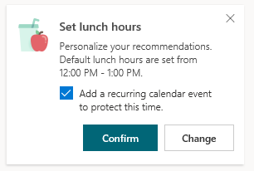
10. Plan your time away | Use this card to plan your time away from work.  a. If the Insights pane isn't shown, select the Insights icon on your Outlook Home ribbon.  b. In the Insights pane, select Plan your time away to see a checklist of planning options.  c. Select dates - Select Start and End dates for when you'll be out of office, and then select Schedule, which sets up an Out-Of-Office appointment on your calendar for the selected dates. Updating your calendar with out-of-office information is a best practice that’ll set the right expectations with coworkers who want to connect with you.  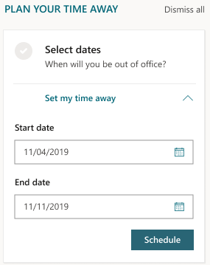  d. Set automatic replies - Compose and save an out-of-office reply message here. Your automatic replies will be sent during the start and end dates you selected. You can select to send the same message to people inside and outside your organization, or you can compose a different auto-reply message for those outside your organization, and then select Save.  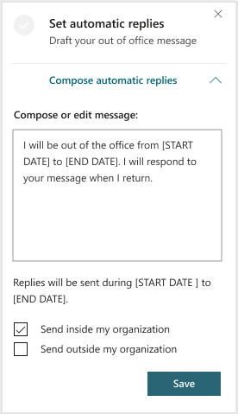  If you've composed a message for a previous out-off-office period, the most recent message that you used is shown in the Compose or edit message field. You can edit the message so that it pertains to your upcoming time away.  e. Notify collaborators - You'll see a list of people that you collaborated with in the last four weeks. You can select to notify them through an email or meeting invitation, and then select Compose.  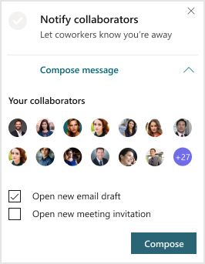  f. Resolve meetings - You'll see a list of meetings you either organized or accepted for while you're away. By using this option to quickly and easily resolve all your meetings, you're saving valuable planning time while also respecting your coworkers’ time.  Decline and cancel meetings with this message - Edit the message that'll be sent to decline or cancel the meeting invitation.  Select meetings to decline and cancel - Select which meetings you want to decline or cancel, or use Select all to decline or cancel all the meetings listed. When you're done, select Confirm. You can also select Open next to a meeting to see more details about it.  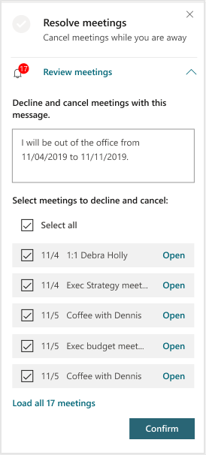  g. Book time to focus - You can schedule time to focus on wrapping up work before you go, and then on catching up after you get back. Select the plus sign (+) next to the available Focus time slots, and then select Done to add them to your calendar. With this time scheduled, you'll know you have time to get everything done both before you go and after you get back.  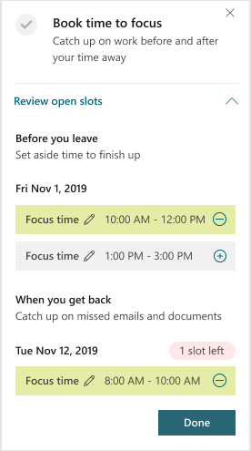
11. Catch up with your team | Stay on top of your team's needs with insights for 1:1 meetings, outstanding tasks, and so on.  a. On Outlook or in Outlook on the web, open the Insights add-in.  b. Select Catch up with your team:  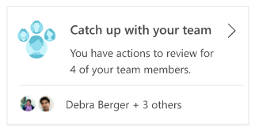  c. The Insights pane shows team members with whom you can reconnect and actions you can take to do so:  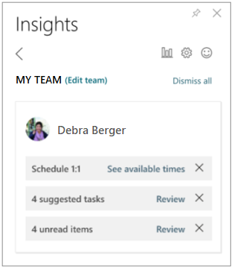  d. If you notice that your team member list is inaccurate, select Edit team to add or remove team members.  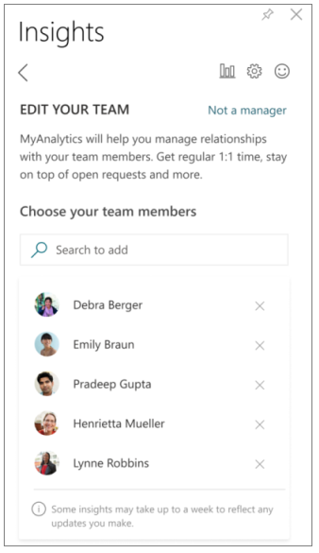
12. Meeting suggestions | Grow and nurture your network by staying connected with important colleagues.  a. In the Insights pane, locate the Meet with <name of contact> insight:  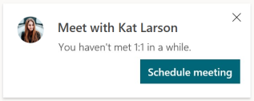
13. Check quiet hours impact | Help your team achieve work-life balance by reviewing the impact of sending email outside of working hours.  a. In the Insights pane, select Check quiet hours impact:  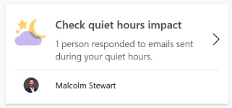  b. This opens a panel that displays insights about emails that might have impacted co-workers outside of their working hours:  